The Two Americas

On April 9th 2018, the FBI conducted a “no-knock” raid on the office, hotel room, and home of Michael Cohen, President Trump’s personal attorney. The unprecedented raid on a sitting President’s personal attorney soon became the focal point of *most* news show that night. The notable exception: Fox News.

Twitter users were particularly hard on Tucker Carlson’s decision to discuss Pandas over covering the raid. A few days later, the Washington Post released this graphic that shows how often “Cohen” was mentioned in three different news organizations.

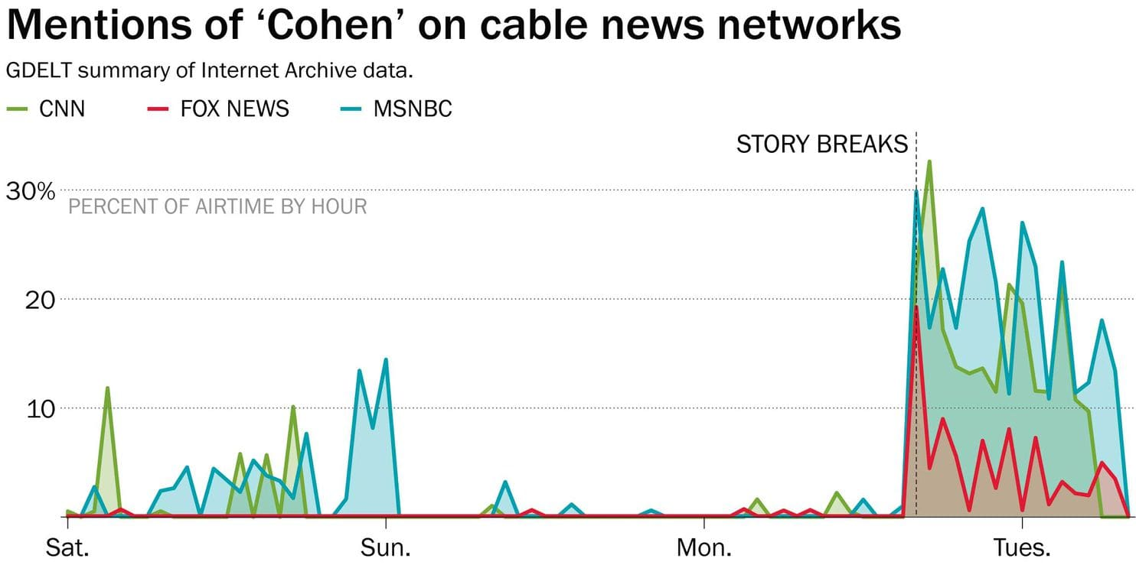

Appearing on David Letterman’s show, *My Guest Needs No Introduction,* Barack Obama said, “One of the biggest challenges we have to our democracy is the degree to which we don’t share a common baseline of facts. What the Russians exploited, but it was already here, is we are operating in completely different information universes. If you watch Fox News, you are living on a different planet than you are if you listen to NPR.”

The Two Americas.

Each group has a vastly different outlook on the world based on the source of their information. Anecdotally, yes, there seems to be a difference between content on Fox News and NPR but does the data back up this claim? To dive into this question further, I looked at [this dataset](https://www.kaggle.com/snapcrack/all-the-news/data) which contains 143,000 articles ranging from 2000 to 2017 across 15 American publications.

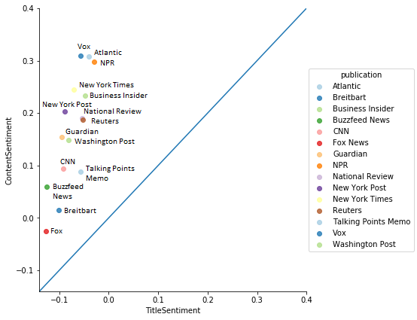

In this graph, I looked at the sentiment value of an article’s title vs the sentiment value of the article’s content for each publication. The sentiment value is a -1 to 1 score that expresses the overall emotion that a sentence conveys with -1 being completely negative and a 1 being completely positive.

The blue line signifies the line where content sentiment = title sentiment. In this graph, any dots that are on this line have the same sentiment value in both their title and content. Any dots above this line have a more positive sentiment value in the content of the article than the title of the article. Any dots below this line have more positive title sentiments than content sentiments.

What does this graph tell us? Across these 15 publications, the title sentiment is always more negative than the content sentiment. This could potentially be related to the need to have shocking, clickbaity headlines to get more readership – it is unclear based on this information provided.

Interestingly, Fox News and NPR are indeed on the polar opposite spectrum when considering overall sentiment. Vox, Atlantic, and NPR are the most positive organizations whereas Fox News and Breitbart are the most negative.

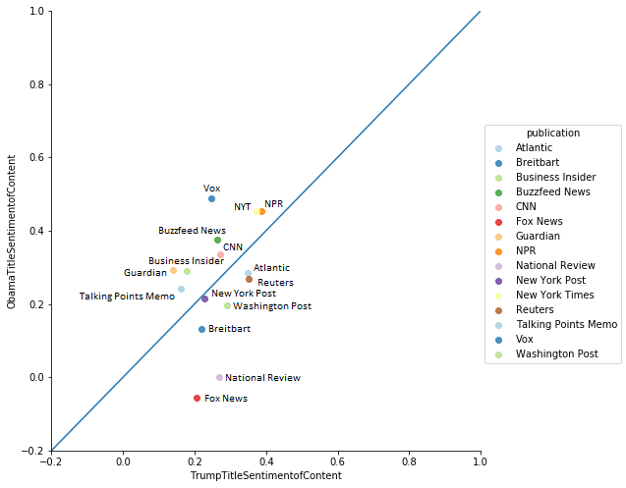

In this graph, I took a look at articles that included “Obama” and “Trump” in the title to see what the sentiment of the article was. Any organization that is on the blue line covered Trump and Obama with the same sentiment value in the article. You can argue, therefore, that the closer an organization is to the blue line, the less bias they have.

We’re seeing a similar trend in this graph compared to the graph before. Whenever Fox news referenced Trump in a headline, the content had a higher sentiment value than whenever they referenced Obama in a headline. On the flip side, whenever Vox referenced Obama in a headline, the content was more positive than whenever they referenced Trump.

The data is showing us that there is a clear difference in how news organizations are covering President Barack Obama and President Donald Trump. This lends credence to the idea that your outlook on the world can drastically change based on where you’re consuming your information from.